The Objective of this work would be identify the superiority conditions of temporal aggregation which might be a function of data characteristics, forecasting method and level of aggregation. We consider both overlapping and non-overlapping temporal aggregation. We try to recommend some rules that couple aggregation approach performance with data characteristic, forecasting method and aggregation level.
Research questions:

We need to decide on the characteristics of data?
What if we look at the characteristics of aggregated data and wee what happens

- What is the relationship between the temporal aggregation performance and data series characteristic?
- Is there any relationship between temporal aggregation performance and forecasting method?
- Can we extract some rules to show under which circumstance (Forecast method, series characteristic, aggregation level, etc) temporal aggregation should be used?
In our work so far, we show that there is a relation between autocorrelation and temporal aggregation superiority under stationary processes, however we don’t know if this is true under other forecast methods, or for other demand processes. It’s very interesting to consider other data characteristics, other forecasting methods, both overlapping and non-Overlapping approaches etc
We start a simulation investigation and then extend the work by considering an empirical analysis using real data sets.
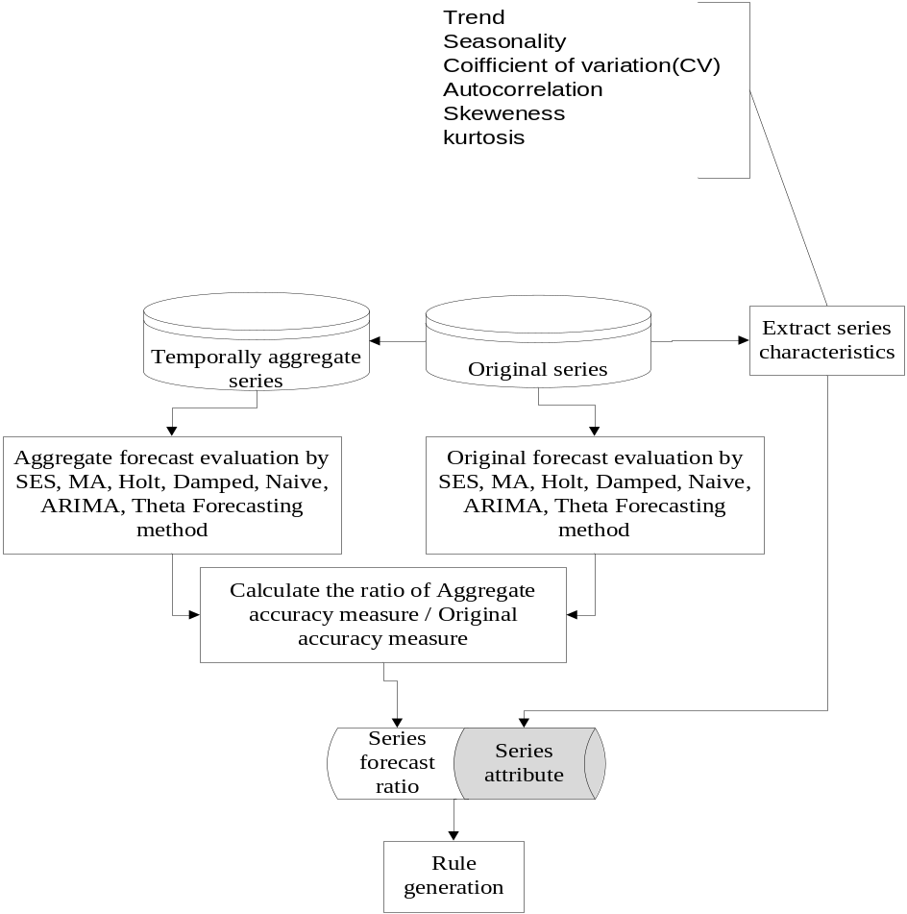

Data characteristics
- Trend
- Seasonality
- Randomness (Chaos)
- Nb of observation
- Autocorerlation

- Cycle/periodicity
- Nonlinear autoregressive structure
- Kurtisos
- Skewness
- Self-similarity (long-range dependence), what is different with Cycle?
- (stochasticity )How do we measure it?

Aggregation type:
- Non-overlapping temporal aggregation
- Overlapping temporal aggregation

Which forecasting methods:
- ETS
- Autoarima
- Theta
- Damped
- SNaïve
- A commercial package like ForecatPro

Which level of comparison
We compare in forecast horizon, in higher level
Our data are monthly, and aggregation level, m=2 to 12

Accuracy measure
MPE,
AvgRelMAE

Relative error, ?
Scalled Mean Absolute Error (sMAE),

